Class I G.K. 2nd August 2019; Friday :
1. Which among the following has three wheels? ____________
i. Truck ii Train iii. Tricycle iv. Bicycle.

2. If, LADYFINGER: VEGETABLE then, CUSTARD APPLE: _________

3. How many noses will 12 children have? _______________

4. Which among the following will not catch fire or burn? __________
i. Paper ii Petrol iii. Wood iv. Water
*****************************************************************

Class II G.K. 2nd August 2019; Friday :
1. On 15th August every year we celebrate the national festival _________
i. Onam ii Independence Day iii. Republic Day iv. Gandhi Jayanti

2. ‘Jana Gana Mana Adhinayaka....’ is the ______________ of our country.
i. School Song ii National Song iii. National Anthem iv. None of these

3. Which among these does not fly in the air?
i. Kite ii Aeroplane iii. Frog iv. Bird

4. If, HAIR: BLACK then, LEAF: _______________
****************************************************************

Class III G.K. 2nd August 2019; Friday :
1. Find the mis-match?
i. blood-red ii. egg-yolk- yellow
iii. spinach-green iv. ice-blue
2. Which among the following is not sticky?
i. water ii. gum iii. honey iv. oil

3. Who among the following was / is a scientist?
i. Pandit Jawaharlal Nehru ii. Mr. Narendra Modi
iii. Mr. A P J Abdul Kalam iv. Mr. Manmohan Singh
4. In which of the following games ‘ball’ is not used?
i. hockey ii. football iii. table tennis iv. kabaddi
****************************************************************
Class IV G.K. 2nd August 2019; Friday
1. Which among the following is not located in Asia?
i. Libya ii. Bhutan iii. Mayanmar iv. China
2. Which among the following is not a neighbouring country of India?
i. Bhutan ii. Nepal iii. Japan iv. Pakistan

3. Which among the following is not a man-made wonder of the world?
i. Mount Everest in the borders of Tibet & Nepal ii. Pyramids of Egypt
iii. Great Wall of China iv. Taj Mahal of Agra
4. Which among the following is a MISMATCH?
i. Gateway of India- Mumbai ii. Sanchi Stupa- Uttar Pradesh
iii. Sun Temple Odisha iv. Jantar Mantar- Jaipur
****************************************************************
Class V G.K. 2nd August 2019; Friday
1. Which among the following is not associated with Tennis?
i. Wimbledon ii. FIFA World Cup iii. French Open iv. Australian Open
2. Which Indian Political Party and its Leader are not correctly matched?
i. INC- Rahul Gandhi ii. TMC- Mamata Banerjee
iii. DMK -MK Stalin iv. SP- Mayawati

3. The longest river of the world is _________________?
i. Amazon- South America ii. Yangtze- Asia
iii. Zaire- Africa iv. Nile- Africa
4. Which among the following is the largest island of the World?
i. Sri Lanka ii. Sumatra iii. Greenland iv. Great Britain
***************************************************************
Class VI G.K. 2nd August 2019; Friday
1. Which among the following notes were scrapped off as announced on 8th November 2016?
i. 10,000 rupee notes [ ] ii. 1,000 & 500 rupee notes [ ]
iii. 500 rupee notes [ ] iv. 50 rupee notes [ ]
2. Name the system that is used in household kitchens and catering units for purification of drinking water? _____________________

3 Which among the following IS INCORRECT?
i. Silk- Mulberry Leaves [ ] ii. Cotton- Jeans [ ]
iii. Jute- Sun-hemp [ ] iv. Salt- Fish [ ]
4. Which among the following is not a Computer Language?
i. BASIC [ ] ii. FORTRAN [ ]
iii. PASCAL [ ] iv. MS- EXCEL [ ]
****************************************************************
Class VII G.K. 2nd August 2019; Friday
1. Which among the following rivers flows eastwards?
i. Tapti [ ] ii. Teesta [ ] iii. Narmada [ ] iv. Sabarmati [ ]
2. Who among the following is the current Chairman of ISRO?
i. Shri K. Sivan [ ] ii. Shri Satish Dhawan [ ]
iii. Shri A S Kiran Kumar [ ] v. Dr. K Radhakrishnan [ ]
3. How many keys are there in the computer keyboard?
i. One Hundred [ ] ii. One hundred and Fifty Six [ ]
iii. One hundred and One [ ] iv. One hundred and four [ ]
4. In which State of India is Lohri celebrated?
i. Assam [ ] ii. Arunachal Pradesh [ ]
iii. Punjab [ ] iv. Karnataka [ ]

****************************************************************
Class VIII G.K. 2nd August 2019; Friday
1. Which among the following rivers flows westwards?
i. Tapti [ ] ii. Teesta [ ]
iii. Mahanadi [ ] iv. Brahmaputra [ ]

2. Who among the following is the current Chairman of ISRO?
i. Shri K. Sivan [ ] ii. Shri Satish Dhawan [ ]
iii. Shri A S Kiran Kumar [ ] iv. Dr. K Radhakrishnan [ ]

3. How many holes does a flute have?
i. Seven [ ] ii. Twelve [ ] iii. Five [ ] iv. Eight [ ]

4. In which State of India is Bihu celebrated?
i. Assam [ ] ii. Arunachal Pradesh [ ] iii. Punjab [ ] iv. Karnataka [ ]
************************************************************************
Class IX G.K. 2nd August 2019; Friday
1. Expand the abbreviation ‘AIIMS’__________________________________________

2. Which among the following cities does not have an IIT- Indian Institute of Technology?
a. Bhilai ( ) b. Kharagpur ( )
c. Powai, Mumbai ( ) d. Dibrugarh ( )

3. The Standard Meridian of India 82⁰ 30’ E passes through which city among the following?
a. Kakinada- AP ( ) b. Mirzapur- UP ( ) c. Bhopal- MP ( ) d. Mandi- HP ( )

4 Who among the following is the creator of the famous painting “Mona Lisa’?
a. Pablo Picasso ( ) b. Leonardo da Vinci ( ) c. Van Gogh ( ) d. Aristotle ( ***********************************************************************
Class X G.K. 2nd August 2019; Friday
1. Which among the following is the largest port of India?
a. Mumbai [ ] b. Paradip [ ] c. Kandla [ ] d. Tuticorin [ ]
2 . Which among the following is the Highest Civilaian Award?
a. Param Veer Chakra [ ] b. Padmabhushan [ ]
c. Bharat Ratna [ ] d. Padmashree [ ]
3 Identify the following logos and name them
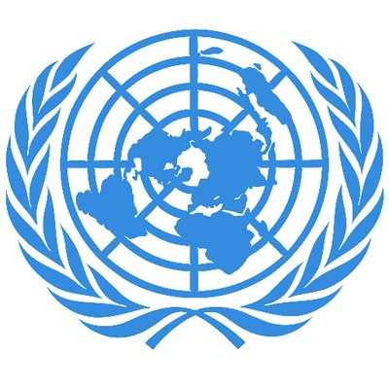
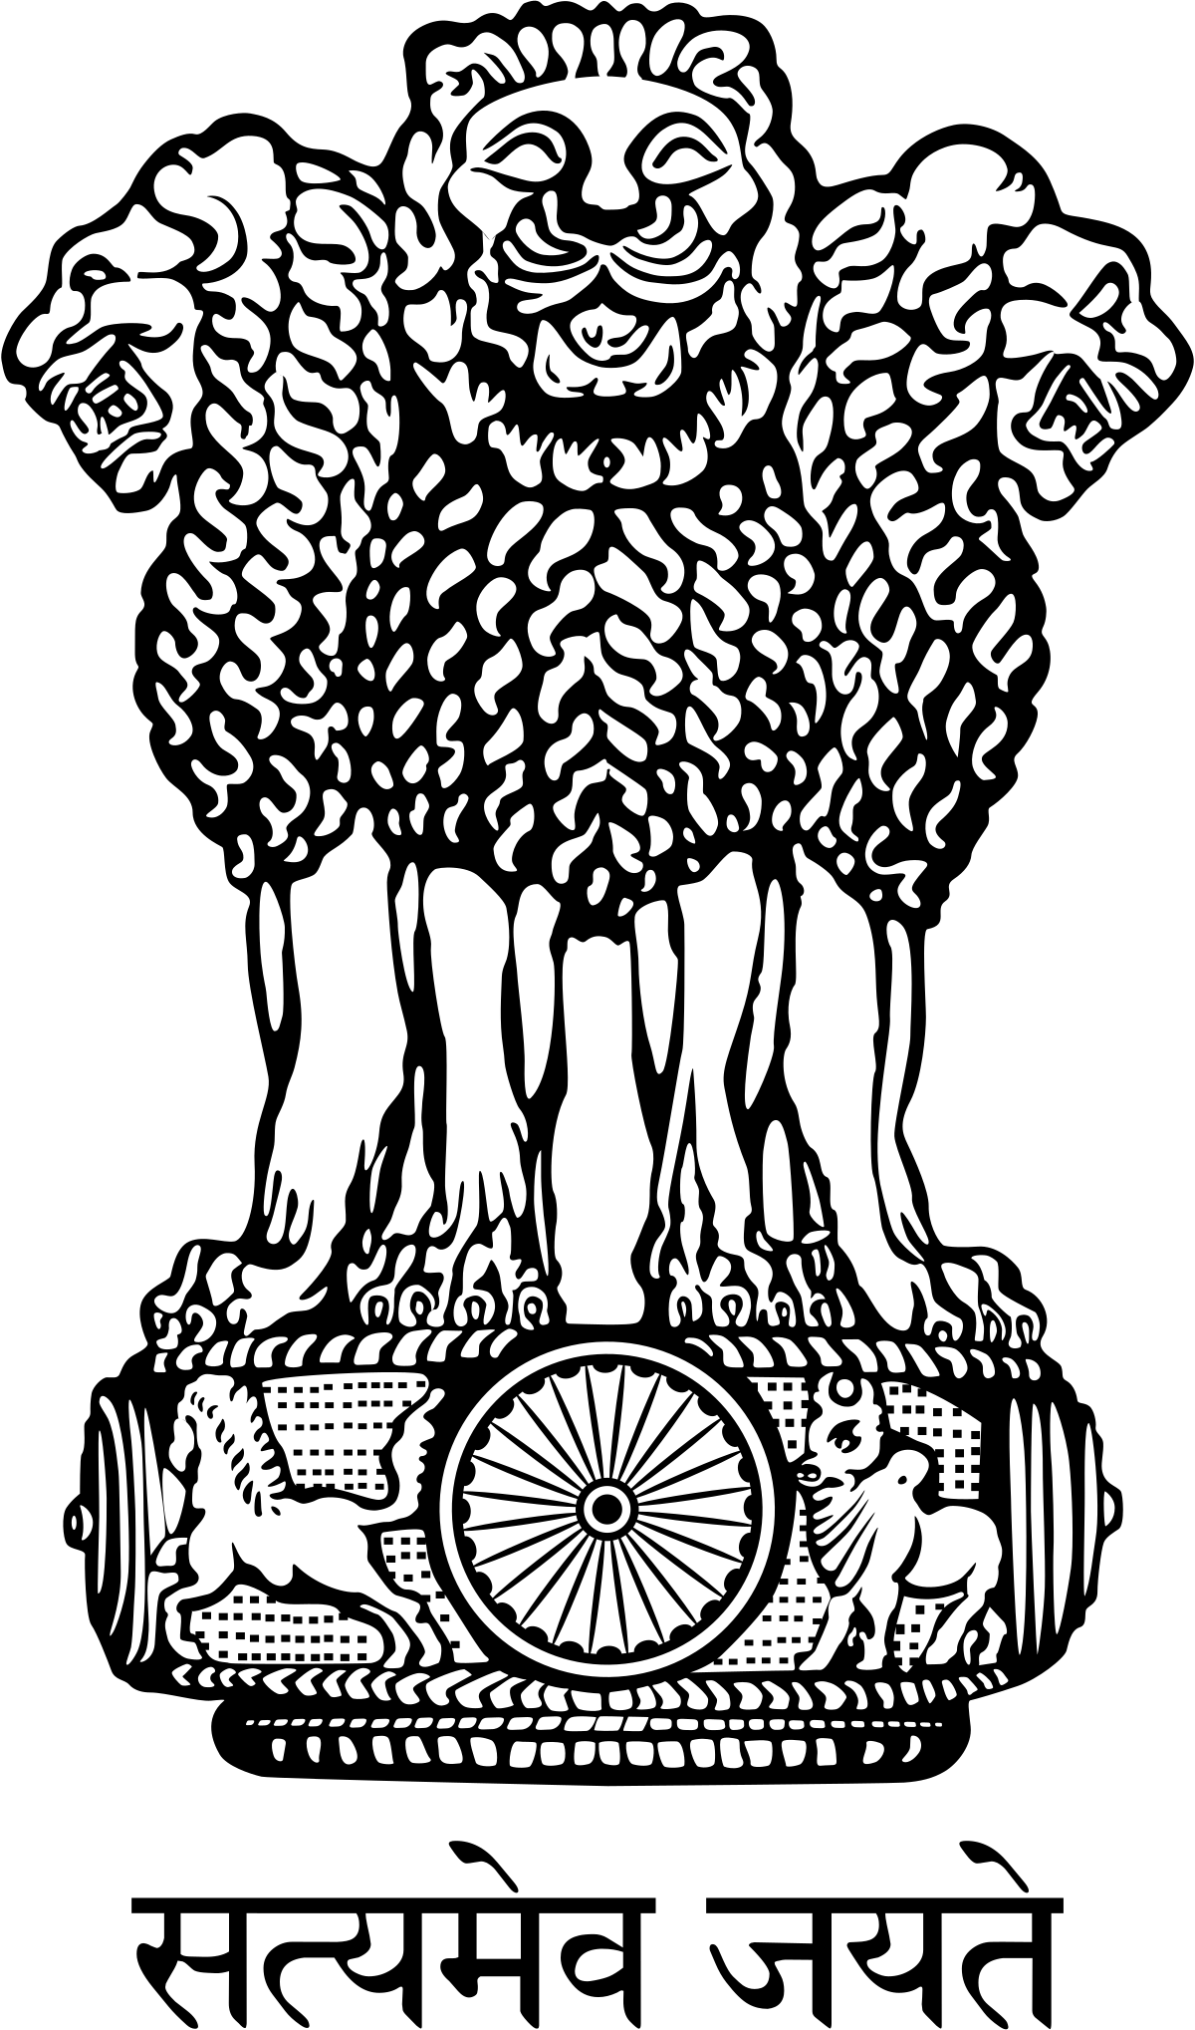

a._________________________________ b._____________________________________
4. Which among the following cities DOES NOT HAVE an Indian Institute of Technology?
a. Bhilai [ ] b. Kharagpur [ ] c. Powai, Mumbai [ ] d. Dibrugarh [ ]
*******************************************************************************
Class XI G.K. 2nd August 2019; Friday
1. Which among the following is the Highest Civilaian Award?
a. Param Veer Chakra [ ] b. Padmabhushan [ ]
c. Bharat Ratna [ ] d. Padmashree [ ]
2. When is International Yoga Day celebrated? ________________________________________
3. Which among the following is not a classical dance form of India?
a. Kuchipudi- Andhra Pradesh[ ] b. Mohiniaattam- Kerala [ ]
c. Odissi- Odishsa [ ] d. Kalbeliya- Gujarat [ ]

4. Give the full form of the ‘One-Nation One-Tax One-Market’ implemented in India on 1st July, 2017 _____________________________________________________________________
***************************************************************

Class XII G.K. 2nd August 2019; Friday
1. Who among the following was trained in Trinity College of London and has contributed a lot to integrate Indian Classical music with electronic instrumental music?
a. Brahmabhatt [ ] b. A R Rahman [ ]
c. Pankaj Udhas [ ] d. Udit Narayan [ ]
2. Which among the following is not synthetic fibre?
a. Rayon[ ] b. Nylon [ ] c. Silk-cotton [ ] d. Chiffon [ ]
3. Identify the logo and write a sentence on each.

____________________________ __________________________

4. Identify the following personalities and write a sentence on each one of them:

 


